**Title, Script, Link & Meta Tags | Web Development Tutorials #4**

**HTML Tutorial: Title, Script, Link, and Meta Tags**

In the last tutorial, we have learned how the basic structure of a website looks like. In this HTML tutorial, we are going to learn about *title, scripts, links,*and *Meta tags.* We will make a new file as “*tut4.html*” and then use basic emmet abbreviation as told previously to get the boilerplate HTML template. The objective of this tutorial is to know completely about HTML heads tag and what these contain.

The Meta Tags are used to define the Meta data in an HTML. They are mainly used in SEO (Search Engine Optimization) techniques which help any particular website to rank better in Google or different search engines. It simply boosts the ranking of a webpage to get more traffic on any website.

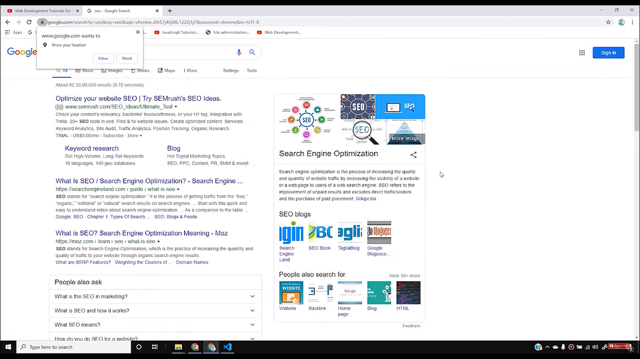

So let us understand various meta tags.

* <meta charset= “UTF-8”>

Copy

- It simply means that the characters that are used will be of UTF-8. It declares the page’s character encoding. It should contain a standard IANA MIME name for character encodings. Moreover, authors are encouraged to use *UTF-8.*

* <meta name= “viewport” content= “width=device-width, initial-scale=1.0">

Copy

- This tag is used to make your website responsive and adjust its width in such a way that it looks good in both PC or mobile. It helps in making the website mobile friendly also.

* <meta http-equiv= “X-UA-Compatible” content= “ie=edge”>

Copy

- It helps any particular website to open in the highest compatibility mode available. It is mostly for those who are still using Internet Explorer. Because there are still some people who have not upgraded their system and are still using the older versions.

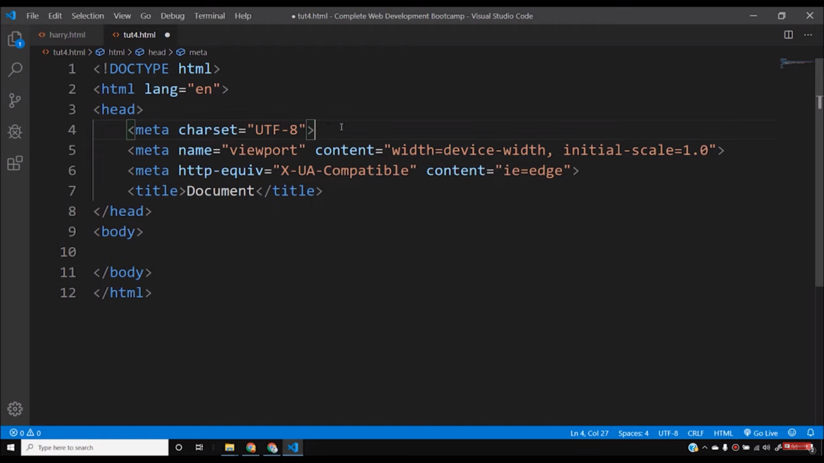

To add descriptions and keywords on our website, we still use meta tags.

* <meta name= “description” content = “This is a description”>

Copy

- To add a description, we have to write the above statement and write your own description in the *content*part.

* <meta name= “keywords” content= “html tutorial, css tutorial”>

Copy

- Keywords are those special words through which a user reach any website. You can add the keywords in the content part of the tag.

If we want our website to be indexed in Google or other search engines and bots should follow all the links present on the website, then we have to write-

<meta name= “robots” content= “INDEX, FOLLOW”>

Copy

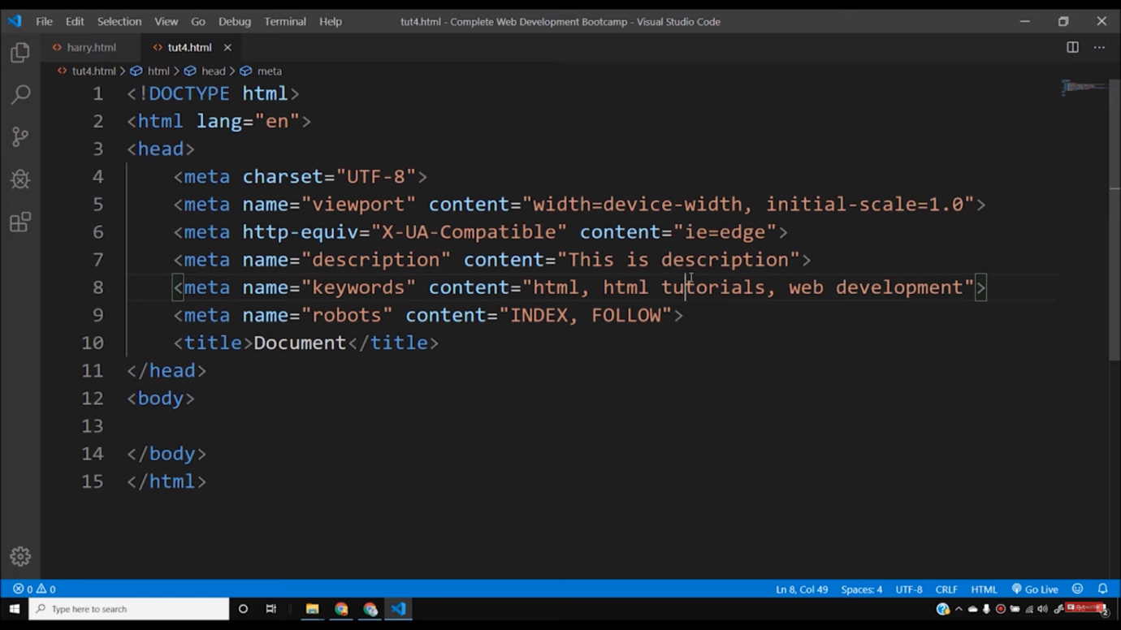

To link our stylesheets named as *“harry.css”* in the HTML code, we have to write-

<link rel= “stylesheet” href= “harry.css”>

Copy

In the same way, as we have included CSS, we can also include a JavaScript file in <head> tag.

<script src = “harry.js”></script>

Copy

I believe you have understood what all things are present in the head tags of the HTML file. In the upcoming tutorials, we will understand the concept of *body* tag where we write the main content of the website.

**Code as described/written in the video**

<!DOCTYPE html>

<html lang="en">

<head>

<meta charset="UTF-8">

<meta name="viewport" content="width=device-width, initial-scale=1.0">

<meta http-equiv="X-UA-Compatible" content="ie=edge">

<meta name="description" content="This is description">

<meta name="keywords" content="html, html tutorials, web development">

<meta name="robots" content="INDEX, FOLLOW">

<title>Document</title>

<!-- This is how you include external css -->

<link rel="stylesheet" href="harry.css">

<!-- This is how you include external JavaScript -->

<script src="harry.js"></script>

</head>

<body>

</body>

</html>

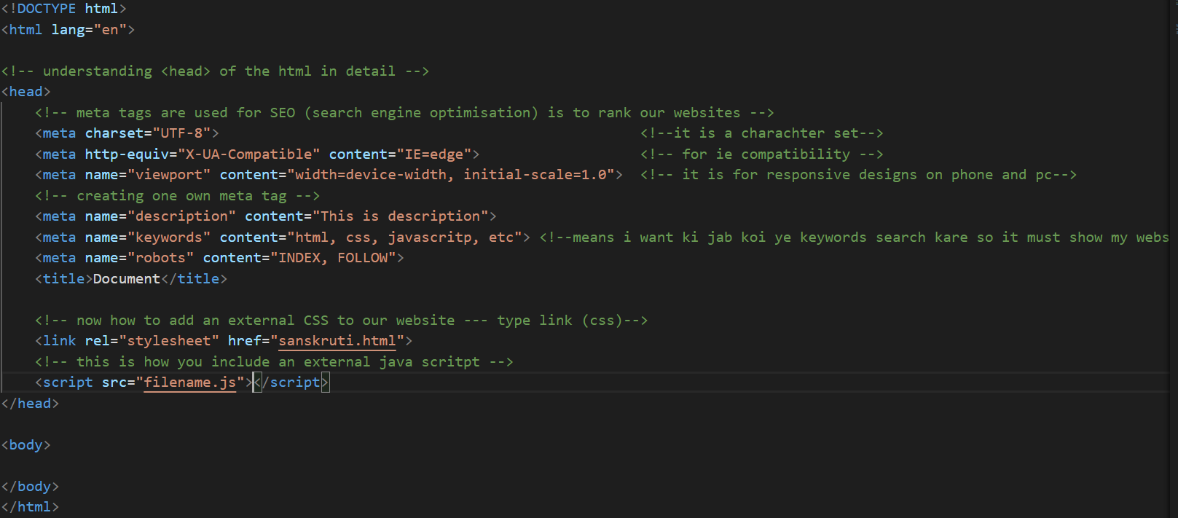

**MORE ON HTML HEAD**

# HTML - The Head Element

[❮ Previous](https://www.w3schools.com/html/html_filepaths.asp)[Next ❯](https://www.w3schools.com/html/html_layout.asp)

The HTML <head> element is a container for the following elements: <title>, <style>, <meta>, <link>, <script>, and <base>.

## **The HTML <head> Element**

The <head> element is a container for metadata (data about data) and is placed between the <html> tag and the <body> tag.

HTML metadata is data about the HTML document. Metadata is not displayed.

Metadata typically define the document title, character set, styles, scripts, and other meta information.

## **The HTML <title> Element**

The <title> element defines the title of the document. The title must be text-only, and it is shown in the browser's title bar or in the page's tab.

The <title> element is required in HTML documents!

The contents of a page title is very important for search engine optimization (SEO)! The page title is used by search engine algorithms to decide the order when listing pages in search results.

The <title> element:

* defines a title in the browser toolbar
* provides a title for the page when it is added to favorites
* displays a title for the page in search engine-results

So, try to make the title as accurate and meaningful as possible!

A simple HTML document:

### **Example**

<!DOCTYPE html>  
<html>  
<head>  
  <title>A Meaningful Page Title</title>  
</head>  
<body>  
  
The content of the document......  
  
</body>  
</html>

[Try it Yourself »](https://www.w3schools.com/html/tryit.asp?filename=tryhtml_head_title)

## **The HTML <style> Element**

The <style> element is used to define style information for a single HTML page:

### **Example**

<style>  
  body {background-color: powderblue;}  
  h1 {color: red;}  
  p {color: blue;}  
</style>

[Try it Yourself »](https://www.w3schools.com/html/tryit.asp?filename=tryhtml_head_style)

ADVERTISEMENT

## **The HTML <link> Element**

The <link> element defines the relationship between the current document and an external resource.  
  
The <link> tag is most often used to link to external style sheets:

### **Example**

<link rel="stylesheet" href="mystyle.css">

[Try it Yourself »](https://www.w3schools.com/html/tryit.asp?filename=tryhtml_head_link)

**Tip:** To learn all about CSS, visit our [CSS Tutorial](https://www.w3schools.com/css/default.asp).

## **The HTML <meta> Element**

The <meta> element is typically used to specify the character set, page description, keywords, author of the document, and viewport settings.

The metadata will not be displayed on the page, but are used by browsers (how to display content or reload page), by search engines (keywords), and other web services.

## **Examples**

**Define the character set used:**

<meta charset="UTF-8">

**Define keywords for search engines:**

<meta name="keywords" content="HTML, CSS, JavaScript">

**Define a description of your web page:**

<meta name="description" content="Free Web tutorials">

**Define the author of a page:**

<meta name="author" content="John Doe">

**Refresh document every 30 seconds:**

<meta http-equiv="refresh" content="30">

**Setting the viewport to make your website look good on all devices:**

<meta name="viewport" content="width=device-width, initial-scale=1.0">

Example of <meta> tags:

### **Example**

<meta charset="UTF-8">  
<meta name="description" content="Free Web tutorials">  
<meta name="keywords" content="HTML, CSS, JavaScript">  
<meta name="author" content="John Doe">

[Try it Yourself »](https://www.w3schools.com/html/tryit.asp?filename=tryhtml_head_meta)

## **Setting The Viewport**

The viewport is the user's visible area of a web page. It varies with the device - it will be smaller on a mobile phone than on a computer screen.

You should include the following <meta> element in all your web pages:

<meta name="viewport" content="width=device-width, initial-scale=1.0">

This gives the browser instructions on how to control the page's dimensions and scaling.

The width=device-width part sets the width of the page to follow the screen-width of the device (which will vary depending on the device).

The initial-scale=1.0 part sets the initial zoom level when the page is first loaded by the browser.

Here is an example of a web page without the viewport meta tag, and the **Tip:** If you are browsing this page with a phone or a tablet, you can click on the two links below to see the difference.

[[](https://www.w3schools.com/html/example_withoutviewport.htm)  
  
**Without the viewport meta tag**](https://www.w3schools.com/html/example_withoutviewport.htm)

[[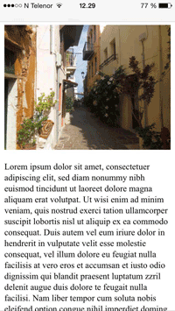](https://www.w3schools.com/html/example_withviewport.htm)  
  
**With the viewport meta tag**](https://www.w3schools.com/html/example_withviewport.htm)

## **The HTML <script> Element**

The <script> element is used to define client-side JavaScripts.

The following JavaScript writes "Hello JavaScript!" into an HTML element with id="demo":

### **Example**

<script>  
function myFunction() {  
  document.getElementById("demo").innerHTML = "Hello JavaScript!";  
}  
</script>

[Try it Yourself »](https://www.w3schools.com/html/tryit.asp?filename=tryhtml_head_script)

**Tip:** To learn all about JavaScript, visit our [JavaScript Tutorial](https://www.w3schools.com/js/default.asp).

## **The HTML <base> Element**

The <base> element specifies the base URL and/or target for all relative URLs in a page.

The <base> tag must have either an href or a target attribute present, or both.

There can only be one single <base> element in a document!

### **Example**

Specify a default URL and a default target for all links on a page:

<head>  
<base href="https://www.w3schools.com/" target="_blank">  
</head>  
  
<body>  
<img src="images/stickman.gif" width="24" height="39" alt="Stickman">  
<a href="tags/tag_base.asp">HTML base Tag</a>  
</body>

[Try it Yourself »](https://www.w3schools.com/html/tryit.asp?filename=tryhtml_head_base)

## **Chapter Summary**

* The <head> element is a container for metadata (data about data)
* The <head> element is placed between the <html> tag and the <body> tag
* The <title> element is required and it defines the title of the document
* The <style> element is used to define style information for a single document
* The <link> tag is most often used to link to external style sheets
* The <meta> element is typically used to specify the character set, page description, keywords, author of the document, and viewport settings
* The <script> element is used to define client-side JavaScripts
* The <base> element specifies the base URL and/or target for all relative URLs in a page

## **HTML head Elements**

|  |  |
| --- | --- |
| **Tag** | **Description** |
| [<head>](https://www.w3schools.com/tags/tag_head.asp) | Defines information about the document |
| [<title>](https://www.w3schools.com/tags/tag_title.asp) | Defines the title of a document |
| [<base>](https://www.w3schools.com/tags/tag_base.asp) | Defines a default address or a default target for all links on a page |
| [<link>](https://www.w3schools.com/tags/tag_link.asp) | Defines the relationship between a document and an external resource |
| [<meta>](https://www.w3schools.com/tags/tag_meta.asp) | Defines metadata about an HTML document |
| [<script>](https://www.w3schools.com/tags/tag_script.asp) | Defines a client-side script |
| [<style>](https://www.w3schools.com/tags/tag_style.asp) | Defines style information for a document |